1. What is LINQ Average Method in C#?

The LINQ Average() Method belongs to the category of Aggregate Operators. The LINQ Average method is used to calculate the average of numeric values from the collection on which it is applied. This Average method can return nullable or non-nullable decimal, float, or double values.

1. Example to Understand Average Method in C#:

Let us understand the LINQ Average() method with Examples using C#. The following example calculates the average of all integers present in the integer collection using both query and method syntax. The point that you need to remember is the Average Method is going to work with numeric values only. In this case, the collection stores integer values, and hence we can apply the LINQ Average Method. We don’t have any operator called average in the LINQ query syntax. So here we need to use mixed syntax.

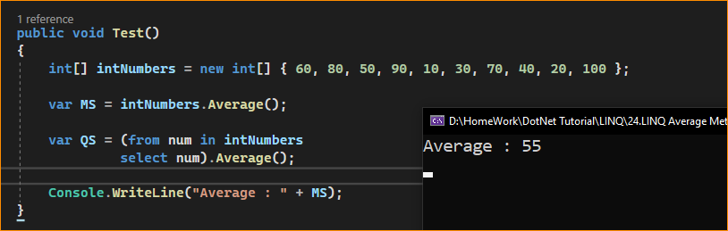

1. Example to Understand LINQ Average Method with Where Extension Method using C#

Let us see an example to Understand how we can use the LINQ Average Method along with the Where Extension Method in C# using both Method and Query Syntax. Now our requirement is to calculate the average of all numbers which is greater than 50. The following example code exactly does the same.

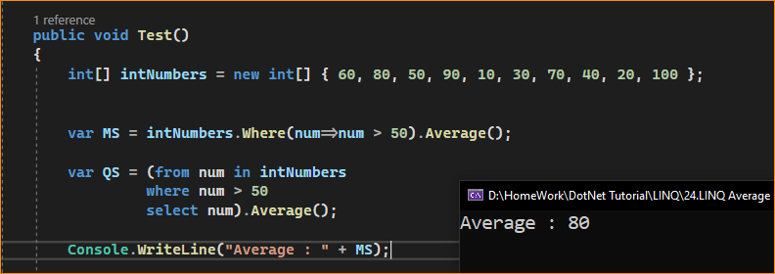

1. Example to Understand How to use LINQ Sum Method with Predicate in C#

Let us see an example to Understand How to use LINQ Average Method with Predicate in C# using both Method and Query Syntax. Instead of using the Where Extension method to filter the data, we can also use the other overloaded version of the Average method which takes a Predicate as a parameter, and within that predicate, we can write the logic to filter the data. In the below example, within the Average Method, we are using a Predicate and we are providing the condition of whether the number is greater than 50 or not. If the number is greater than 50, then we are returning true else we are returning false. The following example will calculate the average of all integers which are greater than 50.

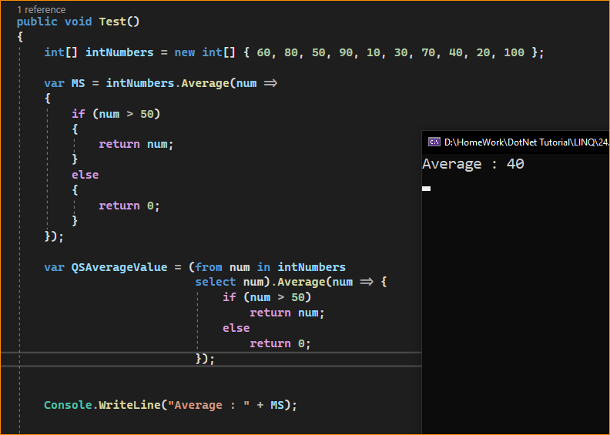

1. Example to Understand LINQ Average Method with Complex Type in C#:

Let us see an example to Understand How to use LINQ Average Method with Complex Type in C# using both Method and Query Syntax. We are going to work with the following Employee class. As you can see, it is a very simple Employee class with four properties such as ID, Name, Salary, and Department. Here, we also created one method i.e. GetAllEmployees() which will return the list of all the employees and this is going to be our data source.

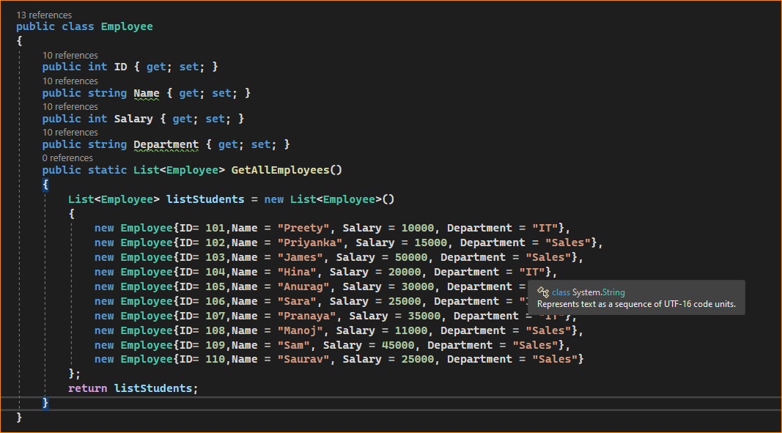

Now, our requirement is to calculate the Average Salaries of all the Employees. The following example calculates the Average Salaries of all employees using the LINQ Average method with both Method and Query Syntax. Here, to the Average method, we are specifying the numeric Salary column using a lambda expression.

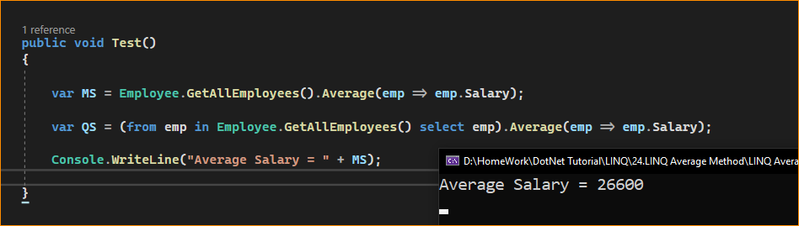

1. Example using Average and Where Extension Method in C#:

Let us see an example to Understand How to use both LINQ Average and Where Extension Methods with Complex Type using both Method and Query Syntax. Our requirement is to calculate the average salary of all the employees who belong to the IT department. The following example exactly does the same. Using the Where Extension Method we are filtering the IT department employees and using the Average method we are specifying the Salary numeric column which will calculate the average salary of IT department employees.

